**Analysis of Freedom Mortgage**

**Customer Complaints**

**09/02/2020**

**James (Nick) Newsome**

This report will explore the customer complaints by Freedom Mortgage customers as well as customers from other major mortgage lenders. The data set was obtained from <https://www.kaggle.com/ashwinik/consumer-complaints-financial-products?select=Consumer_Complaints.csv>. This data is a compilation of customer complaints from 2012 – 2016 that were published by The Consumer Complaint Database. The complaints are published after the company responds, confirming a commercial relationship with the consumer, or after 15 days, whichever comes first. The data is arranged in these 18 columns:

**Date received**: The date that Consumer Complaint Database received the complaint

**Product**: The type of financial product identified by consumer

**Sub-product**: A sub-classification of the various products

**Issue**: The type of issue that the consumer has identified

**Sub-issue**: A sub-classification of the various issues

**Consumer complaint narrative**: The actual written complaint of the consumer

**Company public response**: How the company responded to the complaint

**Company**: Name of company

**State**: State of the consumers address

**ZIP code**: Zip code of the consumers address

**Tags**: Tags that provide easier search and sorting.

**Consumer consent provided?**: Did the consumer opt in to having their complaint made public

**Submitted via**: How was the complaint submitted

**Date sent to company**: When The Consumer Complaint Database sent the complaint to the company

**Company response to consumer**: How did the company respond to the complaint

**Timely response?**: Was the company response timely

**Consumer disputed?**: Did the consumer dispute the company response

**Complaint ID**: Unique ID given to each complaint

In the period between 2012 and 2016, there were 856 complaints submitted against Freedom Mortgage. The vast majority (99.3%) of these complaints are about their mortgage product. As a result of this, further analysis of complaints will be limited to only the mortgage product and all other products will be excluded.

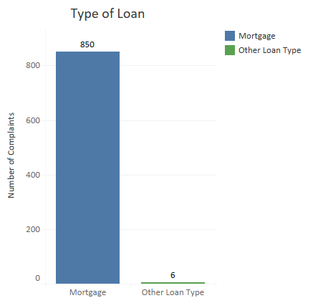

These 850 mortgage complaints have been further divided into sub-categories. The next plot shows the distribution of these sub-categories. So the majority of the complaints were about conventional fixed mortgages followed closely by FHA mortgages, while only 4 of the complaints were about home equity loans or lines of credit. These numbers should be compared to the number of loans Freedom Mortgage has in each of these categories to see if there is a category that is getting substantially more or less complaints than other categories. This data is not available to me though.

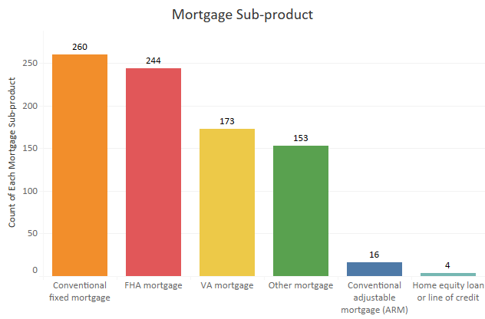

The circle plot below shows how the complaints are separated based off the issue being reported. By far, the largest number of complaints are concerning the loan servicing, payments, or escrow accounts. This may be expected as the number of loans in this department would increase each year as loans would sit in this category for long periods of time and it would accumulate the loans that have passed through the other, much shorter life-span categories.

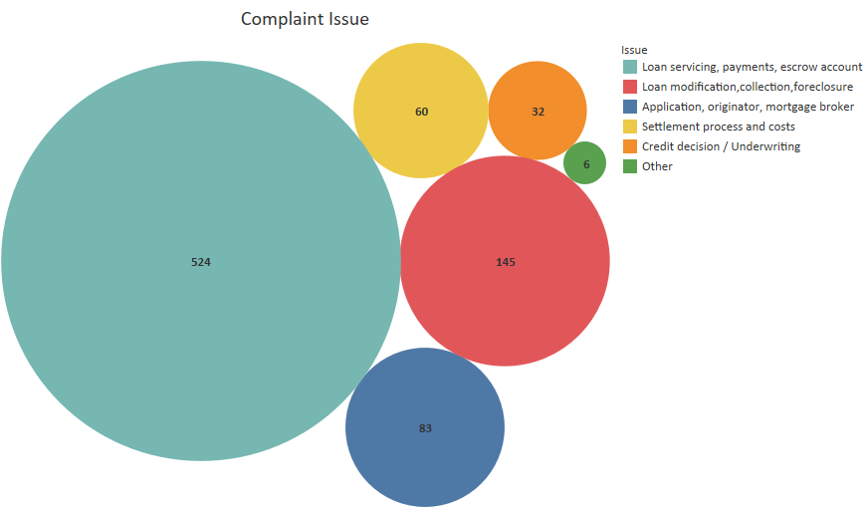

The number of complaints each year shows a possible disturbing trend. The increase in complaints doesn't quite follow an exponential increase, but the significant increase in complaints from 2015 to 2016 makes this the closest trend line fit. More data would be needed to determine if the increase in complaints is relative to an increase in loans. It is quite plausible that even though the number of complaints is increasing, that the percentage of complaints to the number of loans is decreasing. This additional data is not available to me. Based on a word cloud created using Python and an evaluation of these complaints, one possible reason for the increase in complaints came from Freedom Mortgage purchasing loans that originated with other lenders. Based on a few of the reviews, this process was not as smooth as it should have been.

An example of one of these reviews is Complaint ID 588557:

Our Mortgage was sold to Freedom Mortgage when we bought our new home. We originally signed on with XXXX. The transfer was a nightmare that included misinformation, payment dates, and payment amounts. Freedom dropped the ball in all aspects. Then, Freedom Mortgage was late on paying our XXXX taxes. We called to let them know about this issue, we were told that they would handle the late fees incurred. When they got around to paying them ( a month later ), they paid twice and the late fees were charged to our Escrow account. After this payment they conducted an Escrow Analysis, discovered that our Escrow was far into the red. To balance this our Monthly mortgage payment was raised by {$340.00} so they can prevent this from happening in the future. We were in the red because of their double payment. We called and notified Freedom Mortgage of the issue, they're response was that the Escrow Department would look into it and it could take up to 45 days, beyond the date of when the new payment was due. When we inquired about this we were told that if we skipped the increased payment ( which was due to their incompetence ) that we would be charged a late fee and it would negatively affect our credit score, or worse. It was advised that we pay the increased rate until they get the issue worked out on their end. So as a consumer, I am to pay for the issues that they caused until they work towards a "resolution". This is completely unacceptable.

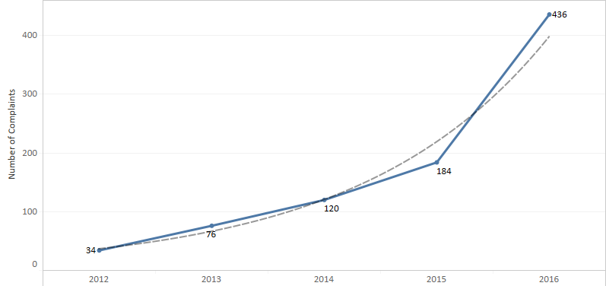

The number of complaints each year can also be broken out by sub-product and by issue. The next two plots do just that.

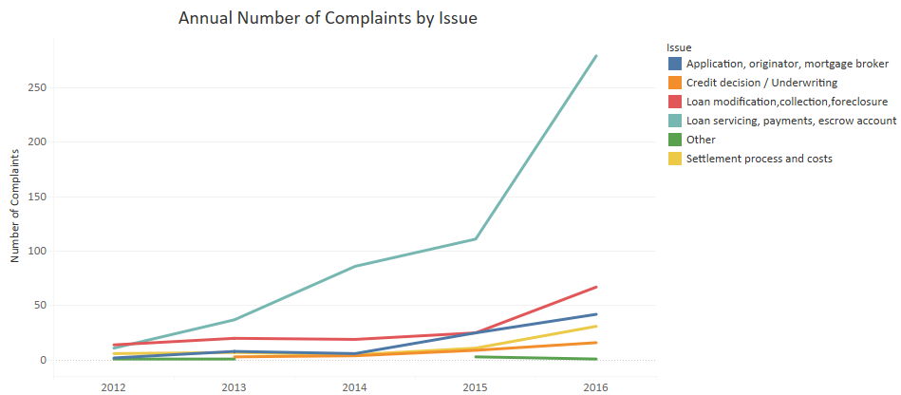

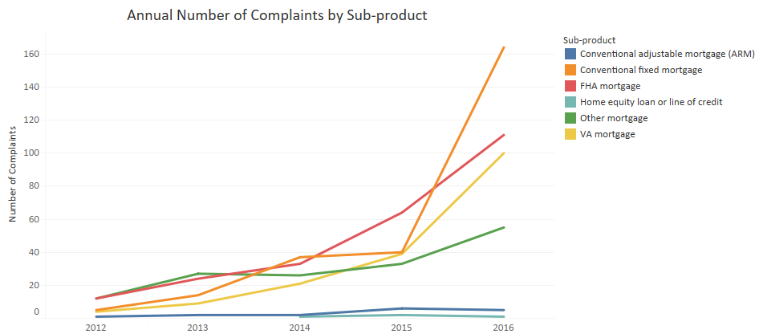

The 'Annual Number of Complaints by Issue' chart seems in line with what would be expected based on the previous circle plot of the total number of complaints by issue. There is a large surge in complaints the loan servicing, payments, and escrow accounts partition. This coincides with a large surge of complaints for conventional fixed mortgages. Either there is a problem with these loan types, or as suggested earlier, these could be the result of poor handling of purchased loans.

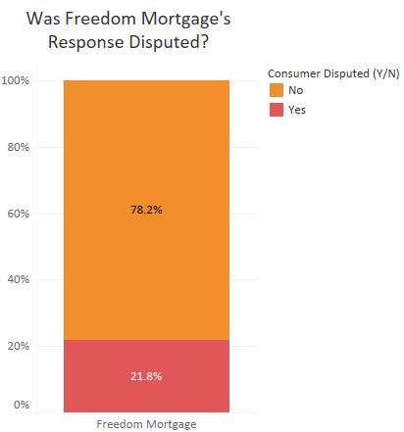These last few charts will look at how Freedom Mortgage responds to the consumer complaint and how the consumer reacts to that response. As the graph to the right shows, less than 22% of consumers disputed the response provided by Freedom Mortgage. Below is the dispute rate for the top 10 mortgage lenders in the US. Freedom Mortgage has the lowest dispute rate of any of these other lenders.

The next page shows how Freedom responds. Almost all of the complaints are responded to with simply an explanation. Less than 1.5% of the complaints result in some sort of relief (monetary or non-monetary) being given. This is in stark contrast to how other companies are handling the complaint. However, as these charts indicate, customers are more likely to accept Freedom's

response.

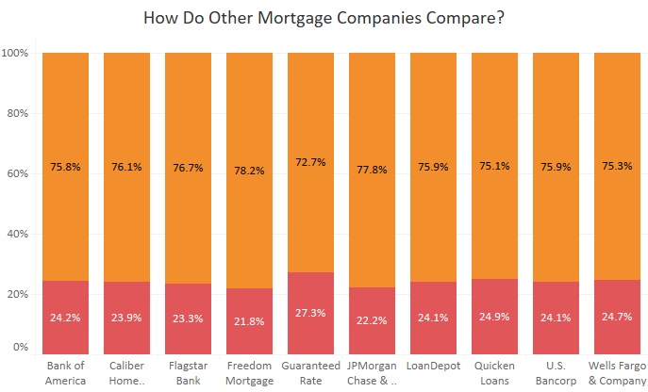

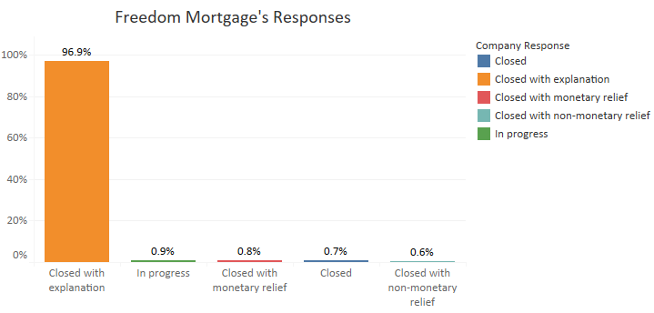

The chart above details Freedom's responses while the one below shows the responses of the other same mortgage companies shown in the charts on the previous page, excluding Freedom Mortgage. This shows that even though the other companies are 8 times more likely to respond with some sort of monetary or non-monetary relief, Freedom Mortgage's response is still less likely to be disputed by the consumer.

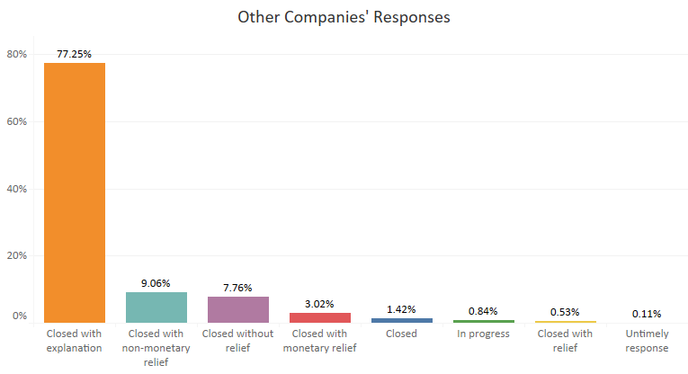

**Conclusion**

The depth of this is limited by data and time. I could not devote the time necessary to inspect this more thoroughly. Additionally there is no available data on the number of loans being processed each year or currently on the books, so conclusions cannot be drawn on why the complaints have increased or how to minimize them. I could also not analyze how the number of complaints compares to that of other companies. While the number of complaints is available, the number of loans is not. So the total number of complaints without being able to put into the context of the size of the loan portfolio offers no insight. There is also no more data available on the responses than the few classification categories. I cannot see what the explanation is, only that the company responded with an explanation. What can be seen is that the responses given by Freedom outperform that of other companies even though relief is rarely given. From a profit standpoint, this should be very advantageous.